

 Notities: UDL- Krachtige leeromgeving op fase 0 en1
Colloquium november 2015
Notities bij de presentatie:
……………………………………………………………………………………………………………………………………………………………………………………………………………………………………………………………………………………………………………………………………………………………………………………………………………………………………………………………………………………………………………………………………………………………………………………………………………………………………………………………………………………………………………………………………………………………………………………………………………………………………………………………………………………………………………………………………………………………………………………………………………………………………………………………………………………………………………………………………………………………………………………………………………………………………………………………………………………………………………………………………………………………………………………………………………………………………………………………………………………………………………………………………………………………………………………………………………………………………………………………………………………………………………………………………………………………………………………………………………………………………………………………………………………………………………………………………………………………………………………………………………………………………………………………………………………………………………………………………………………………………………………………………………………………………………………………………………………………………………………………………………………………………………………………………………………………………………………………………………………………………………………………………………………………………………………………………………………………………………………………………………………………………………………………………………………………………………………………………………………………………………………………………………………………………………………………………………………………………………………………………………………………………………………………………………………………………………………………………………………………………………………………………………………………………………………………………………………………………………………
……………………………………………………………………………………………………………………………………………………………………………………………………………………………………………………………………………………………………………………………………………………………………………………………………………………………………………………………………………………………………………………………………………………………………………………………………………………………………………………………………………………………………………………………………………………………………………………………………………………………………………………………………………………………………………………………………………………………………………………………………………………………………………………………………………………………………………………………………………………………………………………………………………………………………………………………………………………………………………………………………………………………………………………………………………………………………………………………………………………………………………………………………………………………………………………………………………………………………………………………………………………………………………………………………………………………………………………………………………………………………………………………………………………………………………………………………………………………………………………………………………………………………………………………………………………………………………………………………………………………………………………………………………………………………………………………………………………………………………………………………………………………………………………………………………………………………………………………………………………………………………………………………………………………………………………………………………………………………………………………………………………………………………………………………………………………………………………………………………………………………………………………………………………………………………………………………………………………………………………………………………………………………………………………………………………………………………………………………………………………………………………………………………………………………………………………………………………………………………………………………………………………………………………………………………………………………………… ……………………………………………………………………………………………………………………………………………………………………………………………………………………………………………………………………………………………………………………………………………………………………………………………………………………………………………………………………………………………………………………………………………………………………………………………………………………………………………………………………………………………………………………………………………………………………………………………………………………………………………………………………………………………………………………………………………………………………………………………………………………………………………………………………………………………………………………………………………………………………………………………………………………………………………………………………………………………………………………………………………………………………………………………………


UDL:
……………………………………………………………………………………………………………………………………………………………………………………………………………………………………………………………………………………………………………………………………………………………………………………………………………………………………………………………………………………………………………………………………………………………………………………………………………………………………………………………………………………………………………………………………………………………………………………………………………………………………………………………………………………………………………………………………………………………………………………………………………………………………………………………………………………………………………………………………………………………………………………………………………………………………………………………………………………………………………………………………………………………………………………………………………………………………………………………………………………………………………………………………………………………………………………………………………………………………………………………………………………………………………………………………………………………………………………

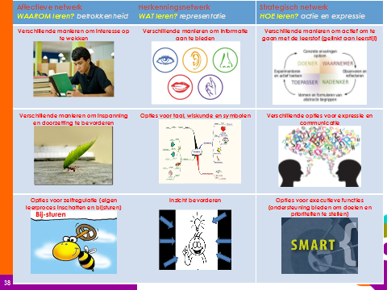

Krachtige leeromgeving:
……………………………………………………………………………………………………………………………………………………………………………………………………………………………………………………………………………………………………………………………………………………………………………………………………………………………………………………………………………………………………………………………………………………………………………………………………………………………………………………………………………………………………………………………………………………………………………………………………………………………………………………………………………………………………………………………………………………………………………………………………………………………………………………………………………………………………………………………………………………………………………………………………………………………………………………………………………………………………………………………………………………………………………………………………………………………………………………………………………………………………………………………………………………………………………………………………………………………………………………………………………………………………………………………………………………………………………………


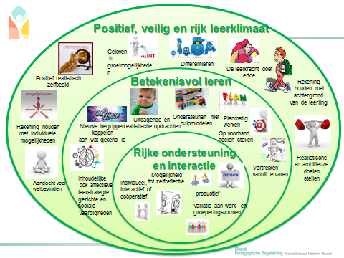

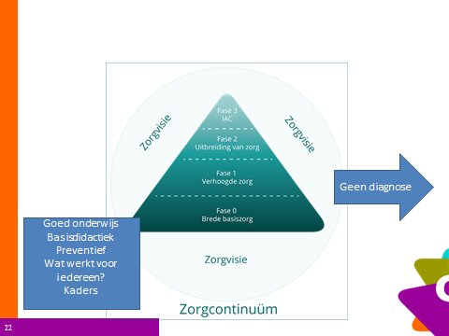…………………………………………………………………………………………………………………………………………………………………………………………………………………………………………………………………………………………………………………………………………………………………………………………………………………………………………………………………………………………………………………………………………………………………………………………………………………………………………………………………………………………………………………………………………………………………………………………………………………………………………………………………………………………………………………………………………………………………………………………………………………………………………………………………………………………………………………………………………………………………………………………………………………………………………………………………………………………………………………………………………………………………………………………………………………………………………………………………………………………………………………………………………………………………………………………………………………………………………………………………………………………………………………………………………………………………………………………………………………………………………………………………………………………………………………………………………………………………………………………………………………………………………………………………………………………………………………………………………………………………………………………………………………………………………………………………………………………………………………………………………………………………………………………………………………………………………………………………………………………………………………………………………………………………………………………………………………………………………………………………………………………………………………………………………………………………………………………………………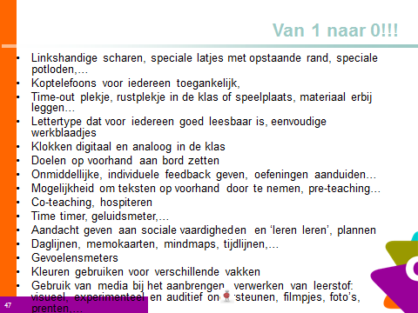………………………………………………………………………………………………………………………………………………………………………………………………………………………………………………………………………………………………………………………………………………………………………………………………………………………………………………………………………………………………………………………………………………………………………………………………………………………………………………………………………………………………………………………………………………………………………………………………………………………………………………………………………………………………………………………………………………………………………………………………………………………………………………………………………………………………………………………………………………………………………………………………………………………………………………………………………………………………………………………………………………………………………………………………………………………………………………………………………………………………………………………………………………………………………………………………………………………………………………………………………………………………………………………………………………………………………………………………………………………………………………………………………………………………………………………………………………………………………………………………………………………………………………………………………………………………………………………………………………………………………………………………………………………………………………………………………………………………………………………………………………………………………………………………………………………………………………………………………………………………………………………………………………………………………………………………………………………………………………………………………………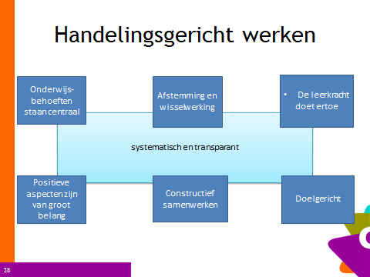
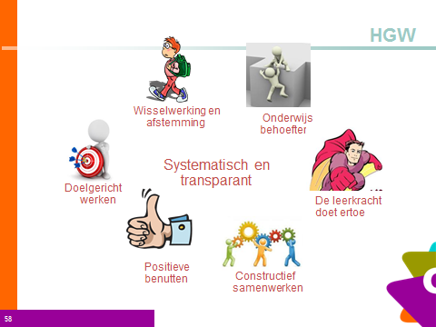…………………………………………………………………………………………………………………………
Welke vragen heb je nog?
…………………………………………………………………………………………………………………………………………………………………………………………………………………………………………………………………………………………………………………………………………………………………………………………………………………………………………………………………………………………………………………………………………………………………………………………………………………………………………………………………………………………………………………………………………………………………………………………………………………………………………………………………………………………………………………………………………………………………………………………………………………………………………………………………………………………………………………………………………………………………………………………………………………………………………………………………………………………………………………………………………………………………………………………………………………………………………………………………………………………………………………………………………………………………………………………………………………………………………………………………………………………………………………………………………………………………………………………………………………………………………………………………………………………………………………………………………………………………………………………………………………………………………



